**OUTPUTS & SCREENSHOTS**

**CHAPTER 8**

**OUTPUT AND SCREENSHOTS**

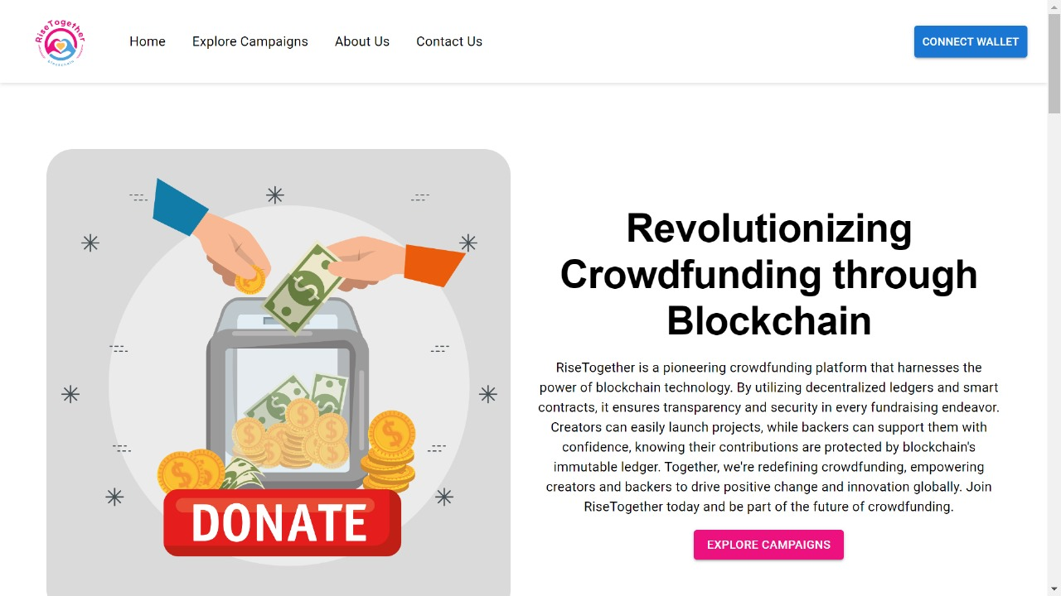**8.1 Outcome of The Project**

Fig 8.1 Homepage

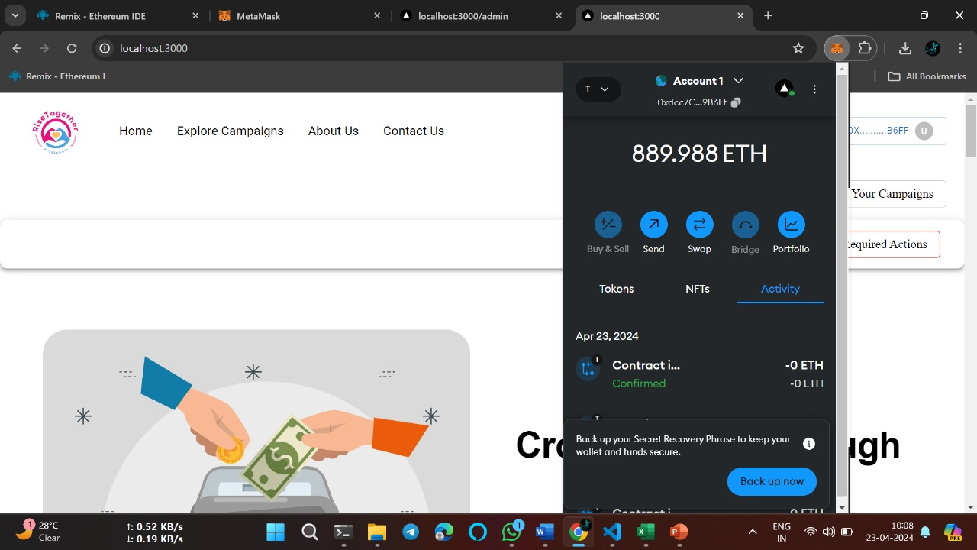

Fig 8.2 Wallet Integration

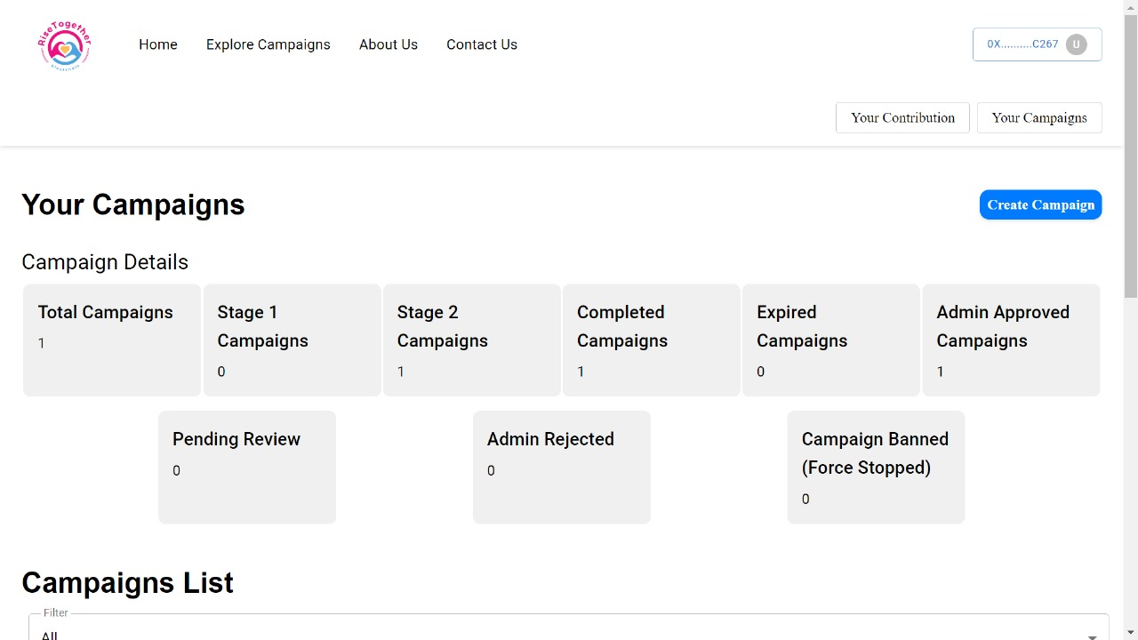

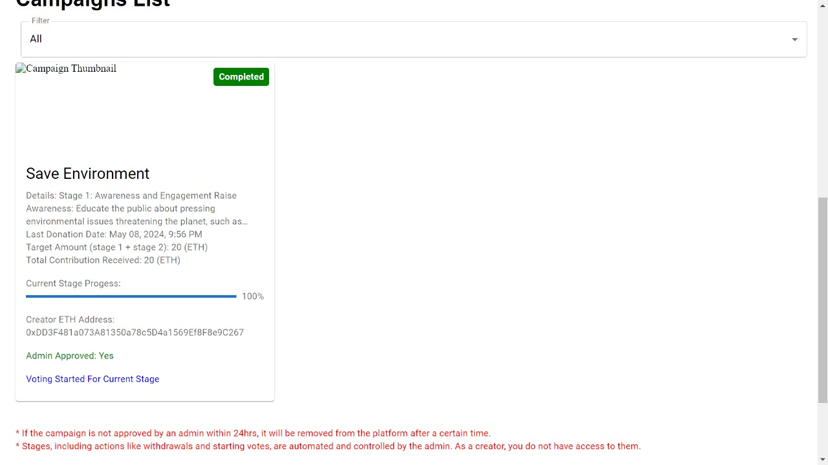**Fig 8.3 UserView-1**

**Fig 8.4 UserView-2**

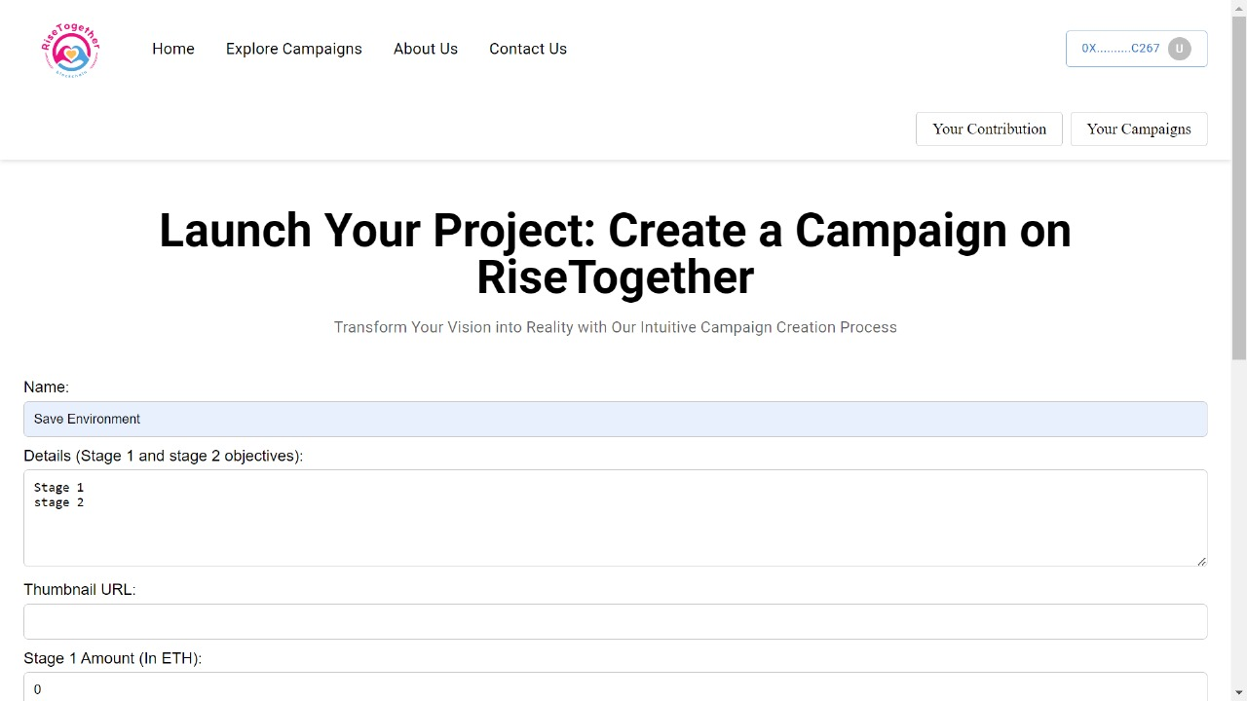

**Fig 8.5 Campaign Creation**

**8.2 Output Summary**

This chapter shows various screenshots of the system. It also shows how data processing happens at various stages of the system and the final output is also displayed. And it also shows the outer interface design of the system.